
MATHEMATICS DEPARTMENT
Year 12 Methods - Test Number 3 - 2017
Applications and Integration
RESOURCE RICH - SOLUTIONS

Multiple-choice questions [2 marks each]
1 y = 3x3 + 4x2+5
y′ = 9x2 + 8x
When x = 2
y′ = 52
δy = 52 × 0.03
= 1.56
D
2 y = 2x3 +12x2 – 18x – 5
y′ = 6x2 + 24x – 18
y″ = 12x + 24
concave upwards when y ″ > 0
12x + 24 > 0
12x > –24
x > –2
B
3 Let the two numbers be x and y.
Then xy = 72 and the sum S = 2x + 4y
Substitute into S = 2x + 4y
S = 2x + 4
S = 2x +
= 2 –
Stationary point when = 0,
2 – = 0
2x2 = 288
x2 = 144, since x is positive
x = 12
y =
y = 6
A

4 The width of each rectangle is 0.25 units and the centres are at x = 0.125, 1.375, 1.625 and 1.875
Heights are f(1.125) = 1.1254, f(1.375) = 1.3754, f(1.625) = 1.6254 and f(1.875) = 1.8754
A = 0.25 × 1.1254 + 0.25 × 1.3754 + 0.25 × 1.6254 + 0.25 × 1.8754
= 0.25 × (1.1254 + 1.3754 + 1.6254 + 1.8754)
∴ D
5 The algebraic area between x = – 4 and x = 1 is negative, so will give the physical area.
∴ E
6
∴ A
7
∴ B
8 The algebraic area between x = 1 and x = 3 is negative, so will give the physical area.
∴ B

9
= – cos – [– cos(0)]
= – + 1
=
=
∴ B
10 Total change =
=
=
=
= 50e1  50e0
= 85.914…
∴ B
11 a The average score is decreasing.
[1 mark]
b The rate at which the average score is decreasing is increasing.
[1 mark]
c [1 mark] for concave downwards for x
[1 mark] for decreasing curve
[1 mark] for y-intercept of 38
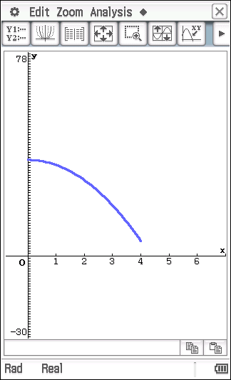

12 Volume = πr2h
500 = πr2h [1 mark]
[1 mark]
Surface area = 2πr2 + 2πrh

[1 mark]

[1 mark]

[1 mark]
[1 mark]

13 a [1 mark]
= (3² – 9 × 3) – (1² – 9 × 1)
= 9 – 27 – 1 + 9
= – 10 [1 mark]
b [1 mark]
= e⁶ – e² [1 mark]
= e²(e⁴ – 1)
c [1 mark]
= sin(π) – sin(0)
= 0 – 0
= 0 [1 mark]

d [1 mark]
= 22 [1 mark]

14 a
[1 mark]
[1 mark]
= 0 [1 mark]
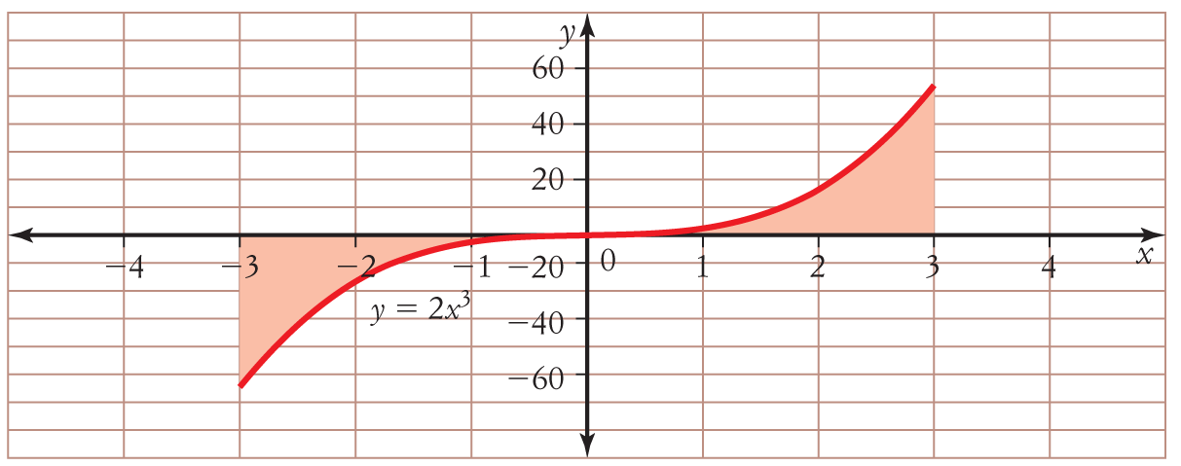
b

[1 mark]
[1 mark]
= 3⁴ – 0⁴
= 81
The area is 81 units². [1 mark]

15 = 8x − 7
y = 4x² − 7x + c [1 mark]
y = 13 when x = −1, so 13 = 4 × (−1)² − 7 × −1 + c
13 = 11 + c
c = 2 [1 mark]
y = 4x² − 7x + 2 [1 mark]

16 Swim to a point approximately 0.89 km along the river towards his camp and then walk approximately 0.11 km to his camp. This will take approximately 42 minutes 22 seconds.
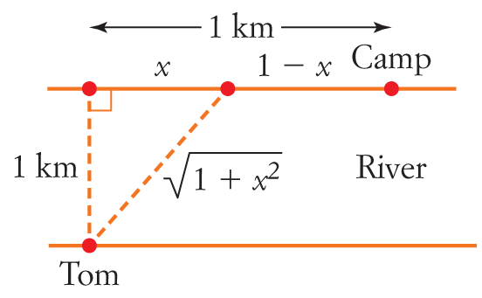
Swim: 2 km/h, Walk: 3 km/h

Time = Swim time + Walk time
[1 mark]
[1 mark]
[1 mark]
[1 mark]
[1 mark]

Substitute into T to find T ≈ 0.706 hours ≈ 42 minutes 22 seconds [1 mark]

17 a [1 mark]
[1 mark]
b [1 mark]
[1 mark]
[1 mark]
[1 mark]

